Case Study:
Emerson Achieves Specification-Level Precision with Oqton’s Thermo-Mechanical Simulation, Eliminating the Need for Interlayer Wait Times

A collaborative study between Emerson and Oqton demonstrates the efficacy of a new thermo-mechanical simulation feature in Oqton's 3DXpert software for compensating for shrinkage in metal additive manufacturing. By applying this simulation to a large 316L demonstrator component, Emerson produced parts with a precision that meets specifications, evidenced by an 80% reduction in dimensional deviation, all while maintaining high machine throughput by eliminating the inter-layer wait times typically required to compensate for overheating.

Technical Challenge: Managing Thermal Deformation in Laser Powder Bed Fusion (L-PBF)

Dimensional inaccuracy due to thermal deformation remains a primary challenge in industrial metal additive manufacturing. This deformation originates from two primary physical phenomena:
- Micro-Level Weld Stress (Inherent Strain): The rapid heating and cooling during the melting process of countless micro-weld paths creates cumulative residual stresses. As layers build upon each other, these stresses lead to global tension and distortion. Inherent strain simulation models are commonly used to predict and mitigate this effect.
- Macro-Level Thermal Effects: During printing, the entire component undergoes significant heating and subsequent cooling. This global temperature fluctuation causes the part to expand and contract, introducing an additional layer of dimensional error that is distinct from weld-induced stress.
While process modifications, such as adding interlayer wait times or additional support structures to stabilize part temperature, can address macro-level effects, they directly increase build time and therefore reduce throughput, making them economically challenging for serial production.

Methodology: Integrated Thermo-Mechanical Simulation
Previously, Oqton 3DXpert featured two independent, industry-proven simulation tools, each targeting a specific physical phenomenon. The Mechanical Simulation module compensated for deformations caused by weld stresses, while the Thermal Simulation module recommended interlayer wait times to mitigate distortions from heat accumulation.
The new thermo-mechanical feature unifies these capabilities. By coupling thermal and mechanical solvers, it creates a comprehensive simulation of the entire printing process. This allows for the generation of a single, optimized pre-deformed model that accounts for both sources of distortion, enabling users to achieve high accuracy on the first print.
For this study, Emerson and Oqton applied the simulation to a large, solid demonstrator part made of 316L, which required a build time of over 20 hours. The simulation predicted significant thermal effects, which would not be fully captured by an inherent strain model alone:
- The thermal simulation predicted that the part would heat up to 390°C.
- This would cause a shrinkage of 720µm in a 100mm section of the part.
- The analysis revealed that 60% of this shrinkage is attributable to the part’s
overheating during the process, an effect that the new thermo-mechanical simulation is specifically designed to capture.

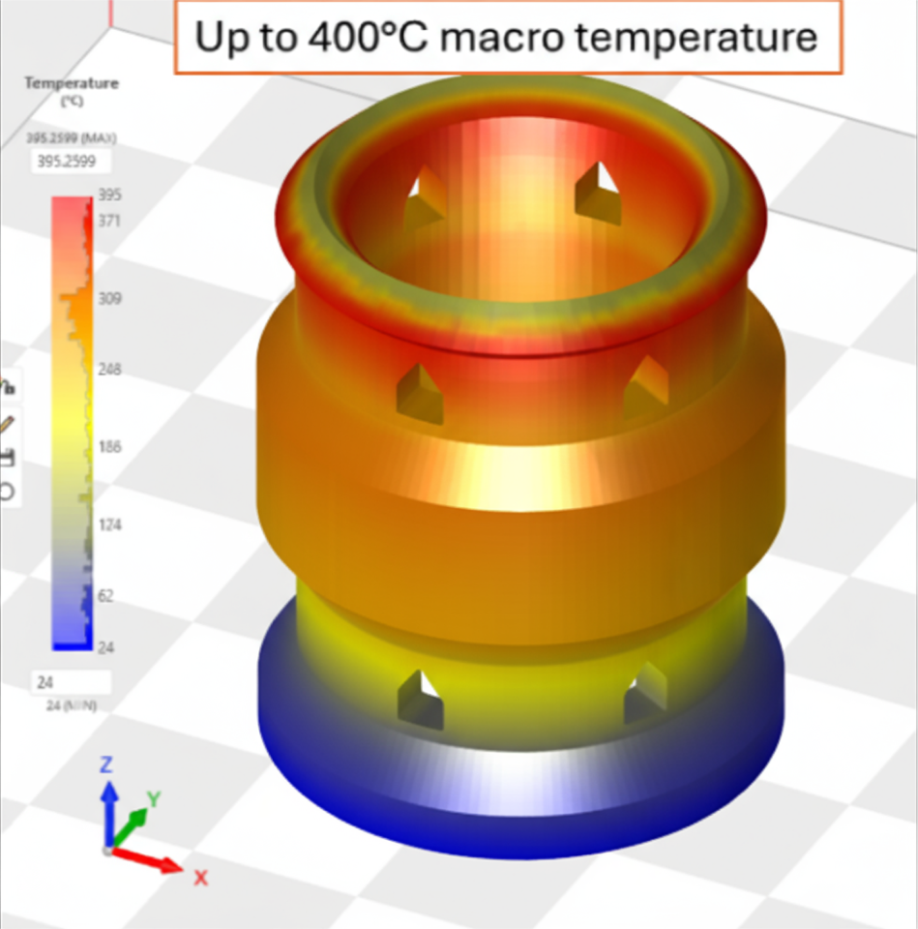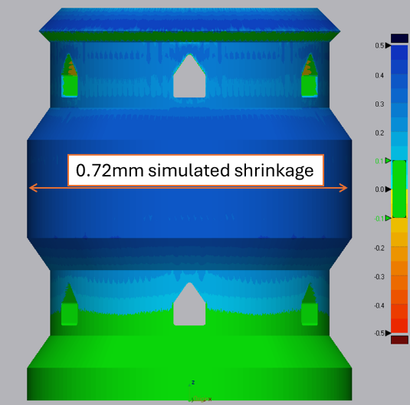

Validation and Results
Using the simulation results, a pre-deformed part was generated and printed without any additional interlayer wait times, thereby maximizing machine throughput. Post-build metrology confirmed the effectiveness of the compensation strategy:
- Overall dimensional deviations were reduced by 80% compared to an uncompensated part.
- The final part achieved an impressive accuracy, with a maximum measured deviation of less than 150µm.

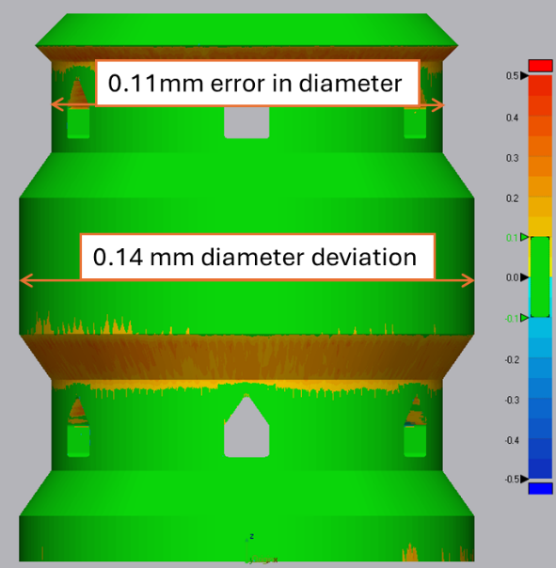

The results of this study validate that an integrated thermo-mechanical simulation can effectively compensate for both inherent strain and global thermal shrinkage. This allows manufacturers to move beyond empirical adjustments and achieve high dimensional accuracy on the first print. The primary benefit for industrial applications is a more predictable, efficient, and cost-effective production workflow for complex metal AM components.

